The Prison and Probation Service
Stavanger prison

Orientation to visitors at Stavanger prison

Visits to the prison will take place in one of our 4 visiting rooms; one of these visiting rooms is equipped with children's toys. Two of the rooms are equipped with glass door, and all visits by persons under 18 years to be completed in one of these. All visiting rooms are non-smoking.

Visits should in principle take place on weekdays of the week and can be booked at set times, which are 15.00, 17.00 and 19.00. The weekends are reserved for visitors who have a long journey and children's visits that cannot be arranged on weekdays, and then at the following time: between 09.00 - 13.00 and 15.30 - 19.00.

Bookings of visits can be made by telephone to Stavanger Prison on telephone 51 73 31 00
Saturdays and Sundays between 09:00 - 12:00 and between 16:00 - 18:00

The visit permit must be brought along with valid identification. The visitor should
document the correct identity, omitting this the visit will be rejected. Carrying bags,
outerwear and other effects will be locked in a closet during the visit.

Food and drink brought with you are not allowed in Stavanger prison. Drinks and various snacks can be purchased in the prison's self-service machine (only takes cards). Permission is not given to bring either mobile phone, watches, photo / video recorder or other electronic devices. It is not possible to bring a pram into the prison. The prison has a rocking chair and a pram bag that can be used during the visit. Pets are also not allowed in the prison.

Gifts to inmates cannot be given directly to inmates, and must be delivered to prison staff before the visit starts.

If the visitor wants to give inmates monetary gifts, it is desirable that the money is sent to the inmates via bank / online banking to the prison's account no. 3201.27.23880
Address
Stavanger prison
Box 5031
4084 Stavanger
PS! Remember to mark any giro with the inmate's name or inmate number.

We ask all visitors to comply with current visiting rules and the orders given by
Prison officer. In case of violation of the rules, the visit can be canceled. It can as well
be informed that unforeseen events may occur and the visiting department may be closed. If
the visit must for some reason be canceled, you will be informed of this as soon as possible
by telephone from the prison.

Especially about control
We make all visitors aware that everyone must go through a check before you arrive
into prison. Everyone must pass through a metal portal, and we have the opportunity to make an external manual visitation. Control can also be done using a sniffer dog. Visitors must consent to such a visit. In the event of a positive effect on control or if one refuses to be visited, the visit will be rejected, cf. the Penal Enforcement Act § 27 first paragraph. If alcohol or other narcotic drugs are suspected, the visit will be rejected. Smuggling of drugs is a criminal offense and can lead to criminal liability.

If health reasons make it difficult to control you, please inform Stavanger Prison about this in advance of the visit.

The visitor can be detained for up to 4 hours until the police arrive if the check gives a positive result, or if there is reason to believe that visitors are trying to bring along objects that are not allowed into the prison.

We carry out all inspections in the gentlest way possible for the visitor.

Visits by children
Especially regarding visits by children in accordance with the Execution of Sentences Act § 31, 7 paragraph, the prison shall facilitate the conditions for visits by children to be carried out in a gentle manner.
The officials at the prison will act as discreetly as possible in relation to control and internal
routines such as lock in and lockout. If it is in the best interests of the child, there are opportunities to give access to extended - or more frequent visits to the prison.

When visiting children, it is important that the guardian tell the child about the check before the visit is carried out in order to spare the child as much as possible.

Stavanger prison has an employee who is responsible for children. This person has the task of ensuring that all children who wish to do so can receive information about what it is like to be in prison and create the conditions for the best possible framework around visits to prison. The person responsible for children will contact relatives when we receive an application for a visit from a child. The child shall be allowed to comment on visits to the prison.
If you have questions about this, the child manager can be contacted at
postmottak-8415@kriminalomsorg.no

If you as a visitor feel insecure about something before the visit, just ask questions when booking a visit.

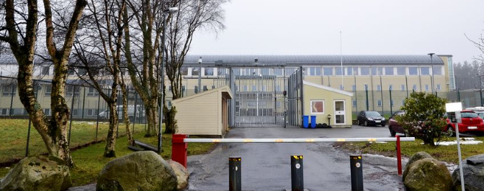
Welcome to Stavanger prison

